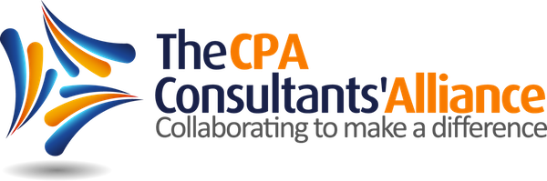

FOR IMMEDIATE RELEASE
FOR MORE INFO:
Sarah Johnson
773.208.7170
sjohnson@inovautus.com

Sandra Wiley
785.341.9473
sandra.wiley@boomer.com

Jen Wilson
402.933.2900
jen@convergencecoaching.com

Top Three Challenges in CPA Firms Identified
At CPA Consultants’ Alliance 2nd Annual Meeting

Overland Park, KS March 4, 2013 – The CPA Consultants’ Alliance (CPACA), a working group of thought leaders united in their efforts to further leadership within the CPA profession, met on February 21st and 22nd for their 2nd annual meeting to identify and discuss the common leadership challenges affecting the CPA profession and look for ways to collectively address these challenges.

The top challenges found continue to center on the themes the group identified in The CPACA 2012 Whitepaper: Communication Drives New Possibilities and are Communication, Learning, and Employee Engagement. “As firms continue to address the imminent leadership succession and transition issues, they are finding that communication, enhanced learning and engaging their talent to be critical to success,” said Sandra Wiley, The CPACA President. “In our work together in 2013, we intend to continue our mission to explore and share solutions to empower the CPA profession and enhance leadership overall.”

The CPACA 2012 Whitepaper identified a huge disconnect between current leadership and the next generation of leadership and encouraged firm leaders to engage their people and open communication to help drive retention and succession. In 2013, the CPACA will provide CPA firms with a number of different resources to assist them in addressing their leadership transition, including webinars featuring firms doing unique things to communicate better, engage their people and facilitate learning. The group will also develop and share additional content around each of the challenges.

For more information on upcoming webinars and to receive regular updates on content, register for the group’s newsletter.
About The CPA Consultants’ Alliance
The CPACA was formed in 2012 with the purpose of exploring leadership issues facing the public accounting profession and developing and sharing solutions that benefit practitioners. Our vision is to inspire positive change in the CPA profession by collaboratively establishing tools and content that will educate, motivate, and increase the wisdom of current and future leaders.
Our members are successful consultants within the CPA profession. The expertise of its members includes CPA firm strategic and succession planning, leadership and management, growth, sales and marketing, information technology, human resources, coaching, mergers and acquisitions, diversity, leadership development and more.
For more information about The CPACA, its members and to stay connected with us, please:
Contact us at: info@cpaconsultantsalliance.com
Visit our Website
Follow us on LinkedIn
Follow us on Twitter
Connect with us on iShade

###

